- Know the difference between a star, a planet and a satellite.

- Know the reason for eclipses of the sun and moon.

- Draw a rough plan of the solar system putting in the sun, the moon, planets and asteroids

- Be able to explain the reasons for the phases of the Earth’s moon.

- Know the Pole Star and two different ways of finding it.

- Be able to recognise and point out at least three constellations.
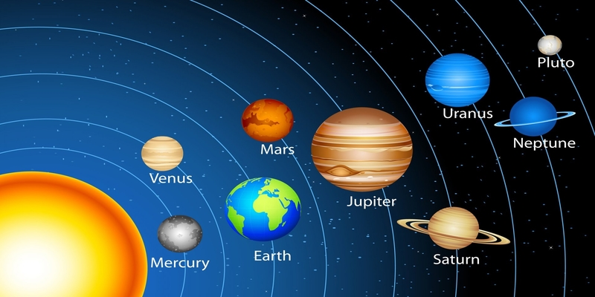

CRAFTSMEN (in addition)
- Know what is meant by galaxy, variable stars, light year and spectrum.

- Be able to explain the terms, red shift, supernova and Milky Way.

A craft suggestion – individual or group.
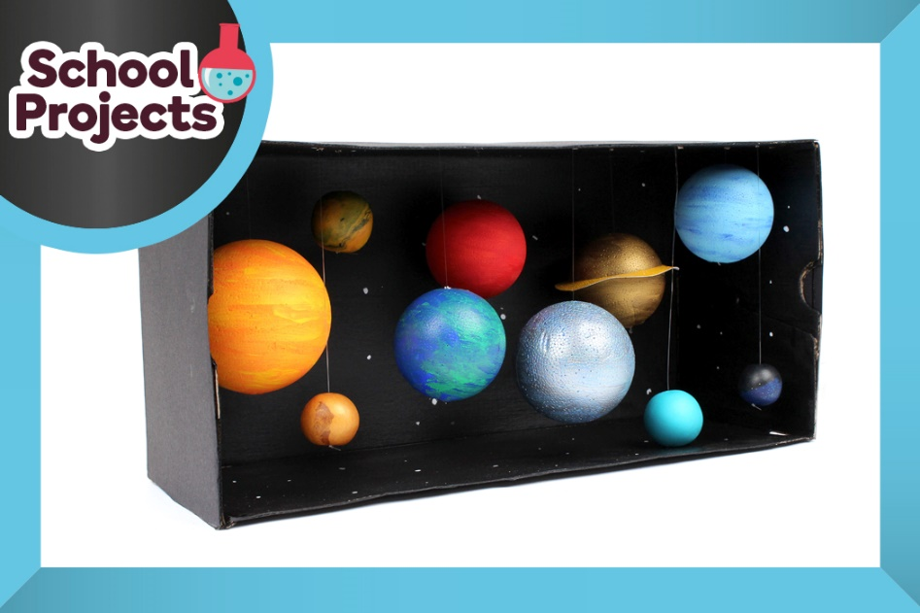

Create your very own solar system using a handful of craft supplies, or why not come up with your very own solar system, you never know what might be out there in a galaxy far, far away!
Project with thanks to Suzie Attaway
How to Make https://youtu.be/3UdEnBQAAzQ

YOU WILL NEED

- Large shoe box
- Black acrylic paint
- White paint pen
- Different sized polystyrene balls
- Bamboo skewers
- Orange, yellow, red, blue, green, silver and gold paint
- Jug or polystyrene block
- Gold paper
- Glue
- Fimo Soft in Peppermint and Sunflower Fimo Effect in Glitter Blue, Agate Stardust and Metallic Gold
- Large needle
- Clear beading thread
- Hot melt glue gun
- Sticky tape
- Black paper

